UK Extended Producer Responsibility (EPR) for Packaging - Fee Modulation Survey
The deadline for responses to the survey is 17:00 on 25 April 2025.
The survey can be accessed here.

- What type of stakeholder are you?
- Large Packaging Obligated Producer (greater than £2m annual turnover and supply or import greater than 50 tonnes per year of packaging on to the UK market), liable to pay pEPR fees
- Other Packaging Producer, not liable to pay pEPR fees
- Trade body or industry representative
- NGO/Charity
- UK local government or council representative
- Waste management company or organisation
- Other

- Which material categories are you most concerned with? (select all that apply)
- All material categories
- Aluminium
- Fibre-Based Composite
- Glass
- Paper or board
- Plastic
- Steel
- Wood
- Other (any materials not listed above - for example, bamboo, ceramic, copper, cork, hemp, rubber, wool, silicone etc.)
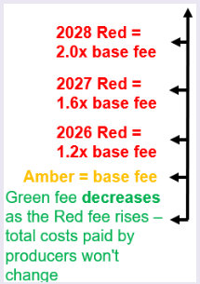
- Do you agree with how we have applied modulation to materials with different RAM categories? Our chosen approach sets amber RAM category fees at base fee, uplifts Red category fees by some modulation factor and then uses the excess raised from Red category materials to discount green fees by a calculated percentage discount (see picture).
- Yes
- No
- Unsure

- How could our fee modulation methodology be improved? Max. 2000 characters.
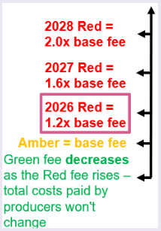
- Do you agree that the initial 2026 fee uplift for Red RAM category materials is at an appropriate level of 1.2 times the base fee, with the entire excess used to discount green category fees?
- Yes
- No
- Unsure

- Is the 1.2x uplift for Red RAM category fees too high or too low in your view?
- Too High (Red fees are too high at 1.2x base fee for 2026 invoices, they should be lower, which will mean a smaller discount for Green RAM category fees)
- Too Low (Red fees are too low at 1.2x base fee for 2026 invoices, they should be higher, which will mean a larger discount for Green RAM category fees)
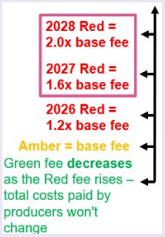
- Do you agree with the policy of increasing Red RAM category fees beyond 2026 – to 1.6 times and 2.0 times base fee in 2027 and 2028, respectively, with a corresponding increase in the green category discount? Are these levels appropriate to drive change?
- Yes
- No
- Unsure

- Are the 1.6 times base fee and 2.0 times base fee factors for Red fees in 2027 and 2028 too low or too high, in your view?
- Too high (Red fees will be too high at the 1.6x and 2.0x factors proposed for 2027 and 2028 invoices, respectively, the Red category fees should be lower, which will mean a smaller discount on Green category fees)
- Too low (Red fees will be too low at the 1.6x and 2.0x factors proposed for 2027 and 2028 invoices, respectively, the Red category fees should be higher to fund a greater discount on Green category fees)

- Having seen the fee factors proposed, do you foresee changing any of your existing plans to use more recyclable materials in your packaging? (Optional: If you do not produce packaging, do you foresee changes in the industry more broadly)?
- Yes
- No
- Unsure

- Add more details (optional). Max 2000 characters.

- How many years of fixed fee factors should PackUK aim to provide in future in advance to provide sufficient certainty and to drive investment in switching to more sustainable packaging?
- 3 years
- 5 years
- 10 years or more
- Unsure

- Please add any comments you would like to share with us regarding fee modulation for packaging Extended Producer Responsibility (optional). Max 3000 characters.

