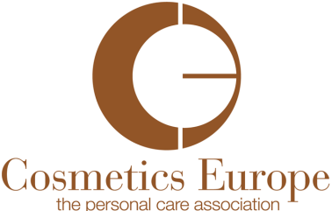

PRESS STATEMENT
COSMETICS EUROPE ISSUES RECOMMENDATION TO DISCONTINUE USE OF MIT IN LEAVE-ON SKIN COSMETICS PRODUCTS

Brussels, 12 December 2013
Cosmetics Europe, the personal care association, is today issuing an industry-wide recommendation to discontinue the use of the preservative Methylisothiazolinone (MIT) in leave-on skin cosmetics and personal care products. The recommendation is made in the interests of consumer health and in response to recent clinical data which shows an increase in adverse skin reactions to this ingredient.
Consumer health and safety is of paramount importance to the cosmetics industry, and we have been working closely with the European Society for Contact Dermatitis to fully understand the emerging data which indicated an increase in the number of people becoming sensitised – or allergic – to MIT.
Following close analysis of clinical data, market feedback and Quantitative Risk Assessment analysis, Cosmetics Europe has concluded that the discontinuation of MIT use in leave-on skin products including cosmetic wet wipes would result in a significant decrease in the incidence of sensitisation to this ingredient.
Cosmetics Europe recommends to the industry that it does not await regulatory intervention under the Cosmetics Regulation, but that it takes voluntary action in implementing this change as soon as feasible.
The full text of the recommendation can be found here:

###

Contact:
Virginia Lee, Director of Communications and Public Affairs
Email: vlee@cosmeticseurope.eu
Tel: +32 2 227 66 30

Notes to Editors:
- MIT (methylisothiazolinone) is a preservative. Preservatives are used in a wide range of cosmetic products to ensure their safety by helping to protect against contamination by micro-organisms. Without preservatives, bacteria, yeast, mould and other organisms could develop, leading to product deterioration, spoilage and potential health and safety issues.

- Preservatives are regulated by cosmetics legislation in Europe, where a list of permitted preservatives is detailed, to ensure that the preservatives used in cosmetics are safe. MIT is a very effective preservative which has been approved in European cosmetic legislation since 2004. It is important also to remember that MIT is used in a very wide range of applications beyond cosmetics, and as such the number of people exposed is high.

- The recommendation is voluntary in its nature and non-binding.

- Cosmetics Europe is the European trade association representing the interests of the cosmetics industry. Its membership consists of 27 national associations of the EU Member States and beyond, 16 major international companies, four supporting association members, three supporting corporate members and three correspondent members associated members. Cosmetics Europe represents more than 4,000 companies throughout the EU via the active representation of its member national associations. For more information about “Cosmetics Europe”, please consult our website: www.cosmeticseurope.eu.

